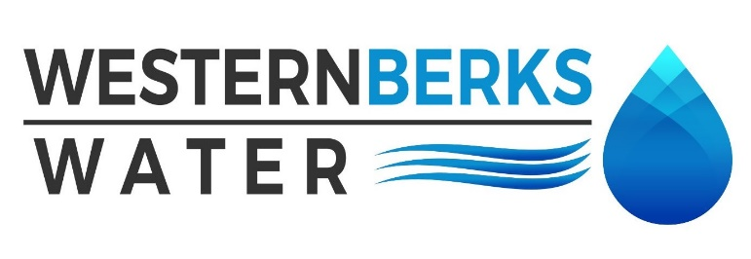

Agenda for Meeting held October 21, 2024

1. APPROVE MINUTES of meeting held September 9, 2024

2. PUBLIC COMMENTS

3. MANAGERS’ REPORTS

A. OPERATIONS MANAGER

1. Water Quality Report

2. Water Sales Report September 2024

B. EXECUTIVE DIRECTOR

1. Capital Project List – review –

2. Office of Open Records – updated Right to Know request form and policy

3. Engineering Inspection Walkthrough

4. Budget and MMO

5. Union Contract

6. Health Care Renewal

7. Mr. Mountz retirement

8. Big Spring

4. MOHRSVILLE REPORT

A. Operational overview

B. Tiny Pear

5. ENGINEER’S REPORT –

A. **Updates** –

6. SOLICITOR’S REPORT

7. AUDITOR’S REPORT –

8. SECRETARY’S REPORT –

9. TREASURER’S REPORT

A. Budget vs. Actual September

B. Approve all September Payments Made

C. Balance Sheet

10. OLD BUSINESS

11. NEW BUSINESS

**A. Next meeting date is Monday, November 11, 2024at 4:30 p.m**

12. EXECUTIVE SESSION – If needed

13. CHAIRMAN’S REMARKS