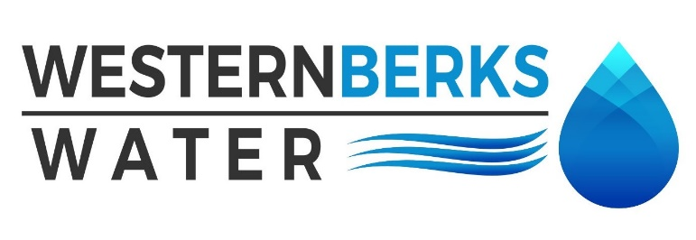

Agenda for Meeting held May 20, 2024

1. APPROVE MINUTES of meeting held April 08, 2024

2. PUBLIC COMMENTS

3. MANAGERS’ REPORTS

A. OPERATIONS MANAGER

1. Water Quality Report

2. Water Sales Report April 2024

B. EXECUTIVE DIRECTOR

1. Capital Project List – review - approve

2. Borough Infrastructure Meeting

3. PA – AWWA Conference - Lancaster

4. MOHRSVILLE REPORT

A. Operational overview

B. Tiny Pear

5. ENGINEER’S REPORT –

A. **Updates** –

6. SOLICITOR’S REPORT

A. Lower Heidelberg Lease Agreement

7. AUDITOR’S REPORT –

A.

8. SECRETARY’S REPORT –

A.

9. TREASURER’S REPORT

A. Budget vs. Actual

B. Approve all April Payments Made

C. Balance Sheet

10. OLD BUSINESS

A.

11. NEW BUSINESS

**A. Next meeting date is Monday, June 10, 2024at 4:30 p.m**

12. EXECUTIVE SESSION – If needed

A.

13. CHAIRMAN’S REMARKS