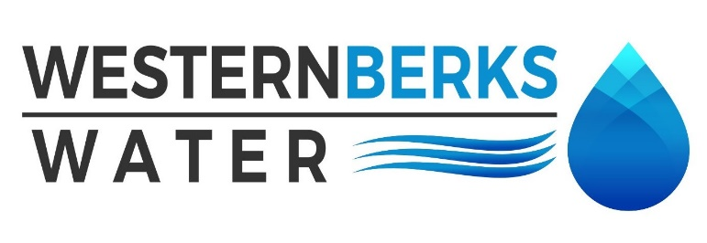
Agenda for Meeting held April 08, 2024

1. APPROVE MINUTES of meeting held March 11, 2024

2. PUBLIC COMMENTS

3. MANAGERS’ REPORTS
A. OPERATIONS MANAGER
1. Water Sales March 2024
2. Water Quality Report

B. EXECUTIVE DIRECTOR
1. Capital Project List – review - approve
2. Big Spring Vended Water update
3. PA-AWWA conference

4. MOHRSVILLE REPORT
A. Operational overview
B. Tiny Pear

5. ENGINEER’S REPORT –
A. Updates –

6. SOLICITOR’S REPORT
A. Tiny Pear Municipal Improvements Agreement
B. Lower Heidelberg Lease

7. AUDITOR’S REPORT –
A. – Financial Statement update

8. SECRETARY’S REPORT –
A.

9. TREASURER’S REPORT
A. Budget vs. Actual
B. Approve all March Payments Made
C. Balance Sheet

10. OLD BUSINESS
A. Holiday Party

11. NEW BUSINESS
A. Next meeting date is Monday, May 20, 2024 at 4:30 p.m

12. EXECUTIVE SESSION – If needed
A.

13. CHAIRMAN’S REMARKS

