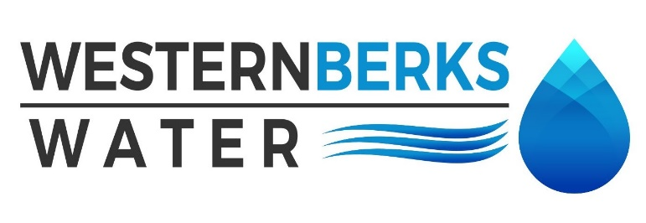
Agenda for Meeting held March 11, 2024

1. APPROVE MINUTES of meeting held February 12, 2024

2. PUBLIC COMMENTS

3. MANAGERS’ REPORTS
A. OPERATIONS MANAGER
1. Water Sales February 2024
2. Water Quality Report
3. Warren Street Bridge Repairs

B. EXECUTIVE DIRECTOR
1. Capital Project List – OCC - High Service Pumps PLC Upgrade $20,530
2. Big Springs Vended Water

4. MOHRSVILLE REPORT
A. Operational overview
B. Tiny Pear

5. ENGINEER’S REPORT –
A. Updates –

6. SOLICITOR’S REPORT
A.

7. AUDITOR’S REPORT -

8. SECRETARY’S REPORT –
A.

9. TREASURER’S REPORT
A. Budget vs. Actual
B. Approve all February Payments Made
C. Balance Sheet

10. OLD BUSINESS
A. Holiday Party

11. NEW BUSINESS
A. Next meeting date is Monday, April 8, 2024 at 4:30 p.m

12. EXECUTIVE SESSION – If needed
A.

13. CHAIRMAN’S REMARKS

